EE368/CS232 Project Proposal

Star Pattern Detection

Suyao Ji, Xiaoge Liu, Jinzhi Wang

It is of great interest for skygazers and amateur photographers to take pictures of the sky, and recognize different star patterns. For this project, we seek to use the techniques outlined in class to develop a constellation detection image process.

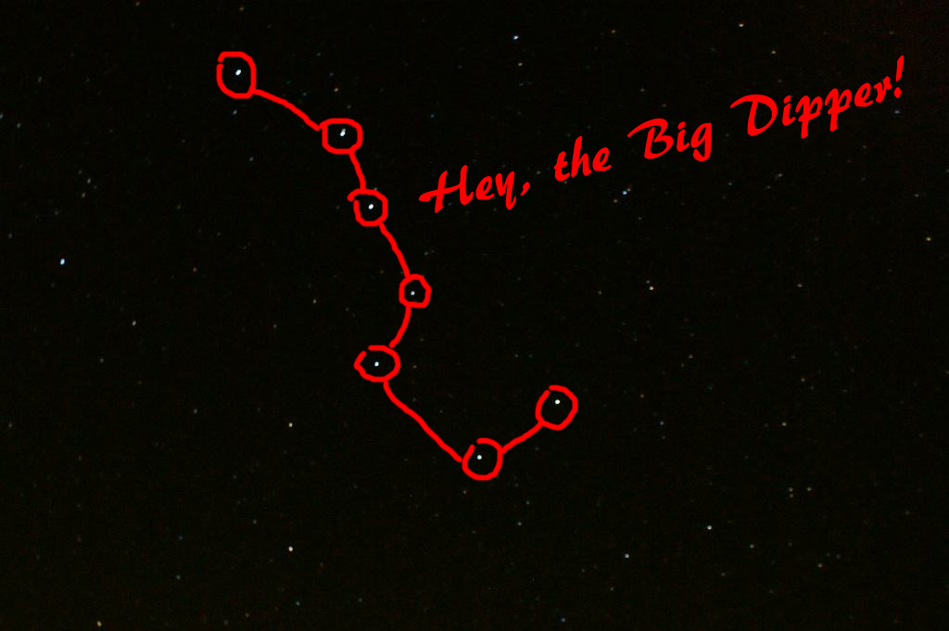

There are 88 officially recognized constellations covering the entire sky. One obvious feature of constellation is that stars of it have a fixed and unique relative position [1]. Triangle algorithm is used widely in the field of star recognition[1][2][3], we take similar approach to collect the relative position of each constellation training image as their unique features, and recognize them in test images with their features if the similarity score is above certain thresholds.

Our proposed image processing steps are summarized as below:

1. Taking photos of dark sky always requires long exposure time, which easily generates blurred image. We can apply noise reduction technique such as wiener filtering to recover the photo.

2. Apply Ostu’s method together with hit-miss filter to filter out noise as well as irrelevant dim stars. Thus stars are sorted based on the brightness. (Usually the constellation stars are much brighter than the other stars and they don’t overlap each other, because the ancient Greek divide the star into constellation by their naked eyes.)

3. Create templates of constellations, which store the relative positions of each star. (For example, in the Big Dipper template, each star should have 6 2-d vectors, which stores the relative position from one other star to itself, we treat the connection of two stars as the x-axis of our choice of coordinate axis.

4. For any given bright point in the image generated from step 2, we check whether there exist stars at its relative positions recorded in the constellation template. Once it matches the feature of the template, this area is determined and removed from the search list. We repeat step 4 for next brightest star until the undetermined region area is below some value.

If accurate detections of star patterns are met, then we would like to extend the concept to be able to handle more complicated image conditions, such as with North pole light background, with non-star light sources in the picture, etc.

References:

[1] Liebe, C. “Pattern Recognition of star Constellations for Spacecraft Applications”, *IEEE AES Systems Magazine, Jan 1993*

[2] Jiang, M., Ye, Y., Yu, M. “A Novel Star Pattern Recognition Algorithm For Star Sensor” *Proceedings of the Sixth International Conference on Machine Learning and Cybernetics, Hong Kong, 19-22 August 2007*

[3] Rehman, M., Fang, J., Faycal, S., Quan, W. “Single Star Identification and Attitude Determination in Tracking Mode” *International Conference on Control, Automation and Systems 2008*